SCHEDULED SPEAKERS FOR AOCO-MASO 2021
6th – 8th APRIL 2021
PLENARY
SPEAKER |  | AFFILIATION | TITLE | SESSION
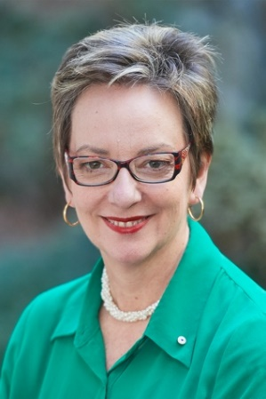 | Prof Dr Louise Baur | University of Sydney, Australia | Evidence and challenges in treating child and adolescent obesity | Plenary 1  (6th April 2021)  9:20 – 10:00 am
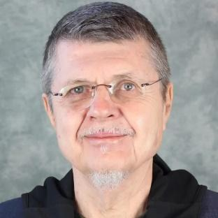 | Prof Dr Adam Drewnowski | Director, Nutritional Science Program, University of Washington, Seattle, USA | Affordable nutrition and economics of obesity | Plenary 2  (7th April 2021)  9:00 – 9:40 am
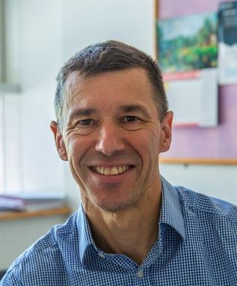 | Prof Dr John Wilding | Department of Cardiovascular and Metabolic Medicine, Institute of Life Course and Medical Sciences, Clinical Sciences Centre, Aintree University Hospital, United Kingdom | Obesity pharmacotherapy – which treatments really work? | Plenary 3  (7th April 2021)  16:20 – 17:00 pm
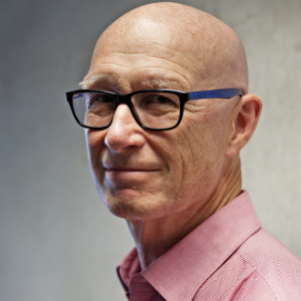 | Prof Dr Boyd Swinburn | University of Auckland, New Zealand | Obesity pandemic turning points – hopeful signs and promising directions | Plenary 4  (8th April 2021)  9:00 – 9:40 am
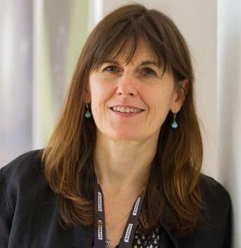 | Prof Dr Karine Clement | Pitié Salpêtrière Hospital and Sorbonne Université, Paris, France | Gut microbiota and obesity: what’s new? | Plenary 5  (8th April 2021)  15:30 – 16:10 pm

SYMPOSIUM SESSIONS
DAY 1: 6th April 2021
SYMPOSIUM 1: Epidemiology of Obesity
10:00 – 11:00 am
SPEAKER |  | AFFILIATION |  | TITLE
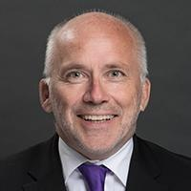 | Prof. Dr. Johan Eriksson | National University of Singapore |  | Obesity from a life course perspective – findings from GUSTO study
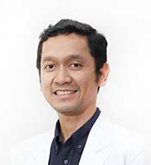 | Dr. Dicky L. Tahapary | Division of Endocrinology, Metabolism, and Diabetes, Department of Internal Medicine, Faculty of Medicine, Universitas Indonesia |  | The Impact of Obesity on Cardiometabolic Complications and Beyond: An Immunoepidemiological Perspective
SYMPOSIUM 2: COVID-19 Pandemic & Obesity
11:00 – 12:00 pm
SPEAKER |  |  | AFFILIATION |  | TITLE
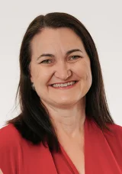 | Prof Dr Caroline Miller | Director of the Health Policy Centre, South Australian Health and Medical Research Institute, Adelaide, Australia. |  | COVID-19 and Obesity: implications for Asian and Oceanian policy.
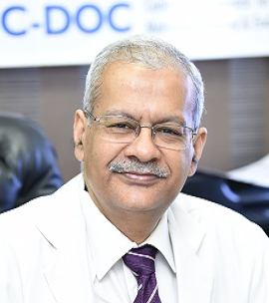 | Prof. Dr. Anoop Misra | Fortis-C-DOC- Centre of Excellence for Diabetes, Metabolic Diseases and Endocrinology, New Delhi, India |  | Obesity and COVID-19 in India
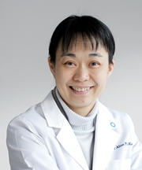 | Prof. Dr. Alice Pik Shan Kong | Division of Endocrinology, Department of Medicine and Therapeutics, The Chinese University of Hong Kong, Hong Kong |  | Covid-19 and Diabesity – what’s the link?
AOASO Rising Stars Symposium (Six Selected Abstracts)
13:00 – 14:30 pm
SYMPOSIUM 3: Mechanistic Underpinnings of Obesity
14:30 – 16:00 pm
SPEAKER |  |  | AFFILIATION |  | TITLE
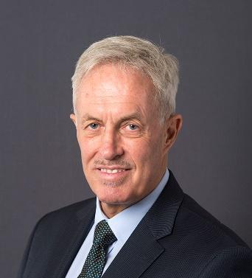 | Prof. Dr. Brian Oldfield | Monash University, Australia |  | Recruitment of postprandial thermogenesis in Brown Adipose Tissue
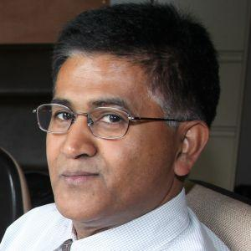 | Prof. Dr. Abdul Dulloo | Laboratory of Nutritional Energetics and Body Composition Regulation, University of Fribourg, Switzerland |  | Famine reactions in pathways to obesity
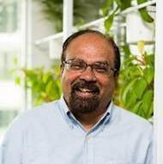 | Prof. Dr. Christiani Jeyakumar Henry | Clinical Nutrition Research Centre, A*STAR Singapore |  | The P-ratio concept in body weight regulation: from a historical perspective
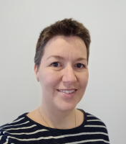 | Dr. Jennifer Miles-Chan | Human Nutrition Unit, School of Biological Sciences, Faculty of Science, University of Auckland, New Zealand |  | Gender-specific differences in obesity predisposition and management
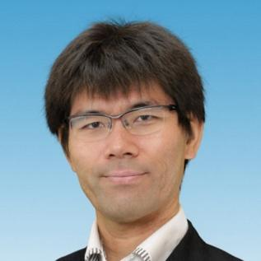 | Dr. Masaharu Kagawa | Institute of Nutrition Sciences, Kagawa Nutrition University, Japan |  | Revisiting proportion of segmental weight in young Japanese female adults
DAY 2: 7th April 2021
SYMPOSIUM 4: Psychological Perspectives in Obesity
9:45 – 10:45 am
SPEAKER |  |  | AFFILIATION |  | TITLE
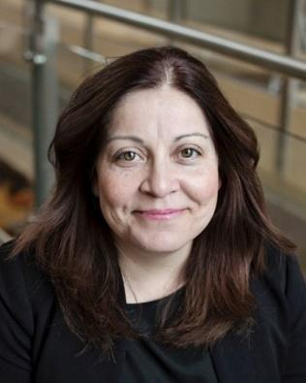 | Dr. Ximena Ramos Salas | Director of Research & Policy, Obesity Canada, University of Alberta, Canada |  | Weight bias and obesity stigma: definitions, prevalence, consequences and strategies for change
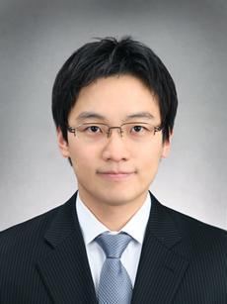 | Prof. Dr. Hyung Jin Choi | Department of Biomedical Sciences & Department of Anatomy and Cell Biology, Seoul National University College of Medicine, Seoul, Republic of Korea |  | Translational Approach for Food Seeking Behavior: Mouse – Monkey – Obesity Patients
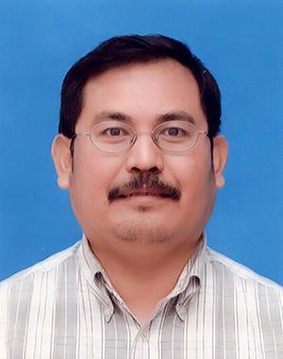 | Prof. Dr. Hatta Sidi | Department of Psychiatry, Universiti Kebangsaan Malaysia Medical Centre, Malaysia |  | TBC
AOASO President Update
10:45 – 12:00 pm
SYMPOSIUM 5: Childhood Obesity
13:00 – 13:45 pm
SPEAKER |  |  | AFFILIATION |  | TITLE
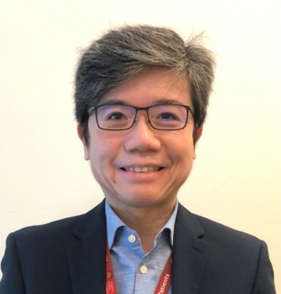 | Assoc. Prof. Dr. Fabian Yap Kok Peng | Head & Senior Consultant, Paediatric Endocrinology, KK Women's and Children's Hospital, Singapore |  | Predicting and preventing childhood obesity: do we need more evidence or newer models of care?
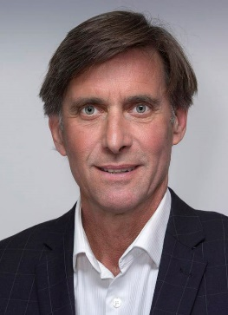 | Prof. Dr. Wayne Cutfield | The Liggins Institute, University of Auckland, New Zealand |  | Microbiome transfer and childhood obesity
SYMPOSIUM 6: Obesity Treatment & Management
14:30 – 15:30 pm
SPEAKER |  |  | AFFILIATION |  | TITLE
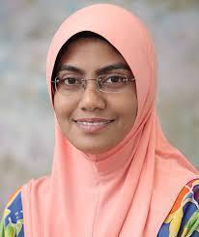 | Assoc. Prof. Dr. Zubaidah Nor Hanipah | Department of Surgery, Faculty of Medicine and Health Sciences, Universiti Putra Malaysia, Malaysia |  | Setting the MDT for morbid obesity
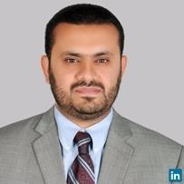 | Assoc. Prof. Dr. Mo’ez Al-Islam Ezzat Faris | Department of Clinical Nutrition and Dietetics, College of Health Sciences, University of Sharjah, United Arab Emirates |  | The effectiveness of intermittent fasting in body weight management and its clinical applications
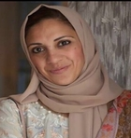 | Ms. Salma Mehar | NHS North West London Collaboration of Clinical Commissioning Groups, London, UK. |  | The REWIND remission programme with low calorie and reduced carbs diets: a dietetic perspective
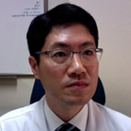 | Prof. Dr. Leonard Kim Kyoung Kon | Department of Family Medicine, Gachon University, Seongnam-si, South Korea |  | Anti-obesity drugs before and after bariatric surgery
SYMPOSIUM 7: Prevention of Obesity
15:30 – 16:15 pm
SPEAKER |  |  | AFFILIATION |  | TITLE
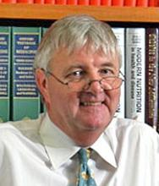 | Prof. Dr. Ian D Caterson | University of Sydney, Australia |  | What positive changes have we seen in our fight with Obesity?
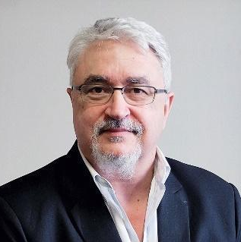 | Prof. Dr. Jean Pierre Poulain | University of Toulouse, France |  | Principle of precaution and circumspection: Elements for a strategy of obesity prevention
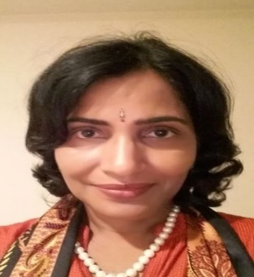 | Prof. Dr. Tilakavati Karupaiah | Taylor’s University, Malaysia |  | Public and Private sectors roles in the food environment of Malaysia
DAY 3: 8th April 2021
SYMPOSIUM 8: Food Security & Obesity
9:45 – 10:45 am
SPEAKER |  |  | AFFILIATION |  | TITLE
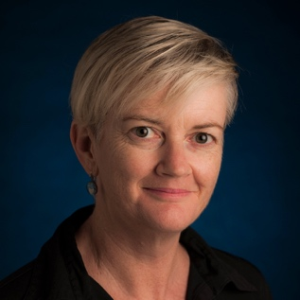 | Prof. Dr. Danielle Gallegos | Queensland University of Technology, Australia |  | Coexistence of Food insecurity and obesity: An Australian Experience and Approach
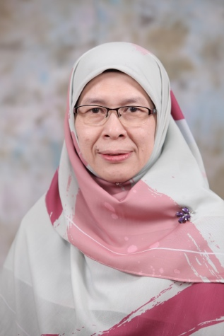 | Assoc Prof. Dr. Norhasmah Sulaiman | Department of Nutrition and Dietetics, Faculty of Medicine and Health Sciences, Universiti Putra Malaysia |  | Not having enough food can cause obesity: Is that possible?
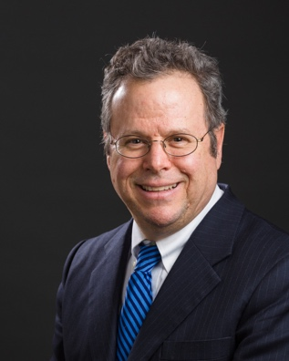 | Prof. Dr. Rafael Perex-Escamilla | Yale School of Public Health, Yale University, New Haven, USA |  | TBC
SYMPOSIUM 9: Bariatric Surgery
10:45 am – 12:00 pm
SPEAKER |  |  | AFFILIATION |  | TITLE
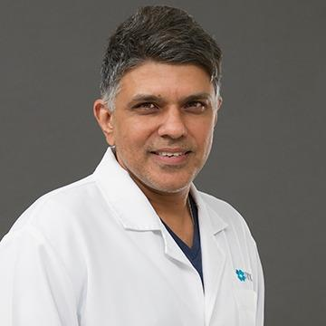 | Dr. Muffazal Lakdawala | Institute of Minimal Invasive Surgical Sciences & Research Centre, Saifee Hospital, Mumbai, India |  | Metabolomic outcomes of bariatric surgery
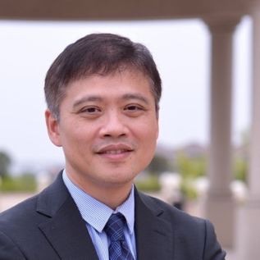 | Dr Chih-Kun Huang | China Medical University Hospital, Taichung, Taiwan |  | cost effectiveness of bariatric surgery-why insurance providers should consider coverage
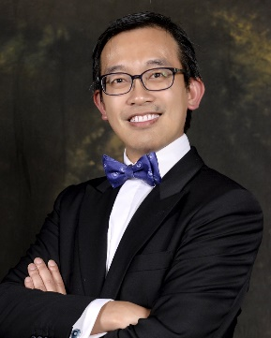 | Dr Simon Wong Kin Hung | Department of Surgery, The Chinese University of Hong Kong. |  | Latest innovations in bariatric procedures
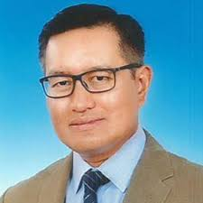 | Prof. Dato’ Dr. Nik Ritza Kosai Nik Mahmood | Department of Surgery, Faculty of Medicine, UKM Specialist Centre |  | History and progress of bariatric surgery in Malaysia
SPEAKER |  |  | AFFILIATION |  | TITLE
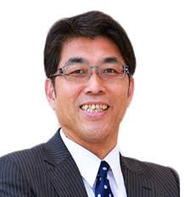 | Prof Masamitsu Nakazato | Department of Internal Medicine, University of Miyazaki, Japan |  | Leap2, a hepatic peptide identified in bariatric surgery research, in metabolic regulation
SYMPOSIUM 10: Lifestyle, Exercise & Diet
13:00 – 12:45 pm
SPEAKER |  |  | AFFILIATION |  | TITLE
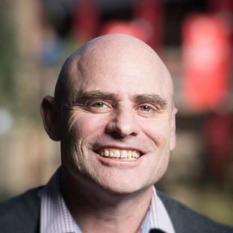 | Prof. Dr. Tony Okely | University of Wollongong, Australia |  | The role of 24 hour movement behaviours in understanding and responding to the global child obesity pandemic (specific focus on Asia-Oceania region
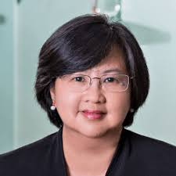 | Prof. Dr. Winnie Chee | Department of Nutrition & Dietetics, International Medical University, Malaysia |  | Structured nutrition in optimizing weight loss
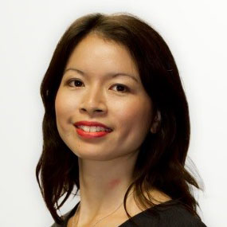 | Dr. Mary Chong Foong Fong | School of Public Health, National University of Singapore, Singapore |  | A web-based, time-use application to assess diet and movement behaviour in Asian schoolchildren
SYMPOSIUM 11: Complications of Obesity
14:45 – 15:30 pm
SPEAKER |  |  | AFFILIATION |  | TITLE
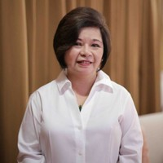 | Dr. Rosa Allyn Sy | Endocrinologist, Cardinal Santos Medical Center, Manila, Philippines |  | Obesity and its complications
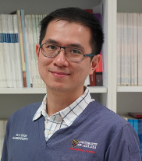 | Prof Dr. Chan Wah Kheong | Gastro-Enterology Unit, Department of Medicine, Universiti Malaya Medical Centre, Malaysia |  | Obesity and non-alcoholic fatty liver disease (NAFLD) latest update

